Ordered works | MSP-06
Maintenance System Procedure | MSP-06
(refer to PSP-M clause 20)
Ordered works are delivered as projects under the RMCC. This procedure describes how work is identified as Ordered Works then assessed and approved by the TfNSW. Ordered works require:
- a project plan as per PSP-M Clause 20 and Attachment 14
- a project risk assessment.
Work Orders arising from incidents are covered by MSP-07 Incident Response.
Process
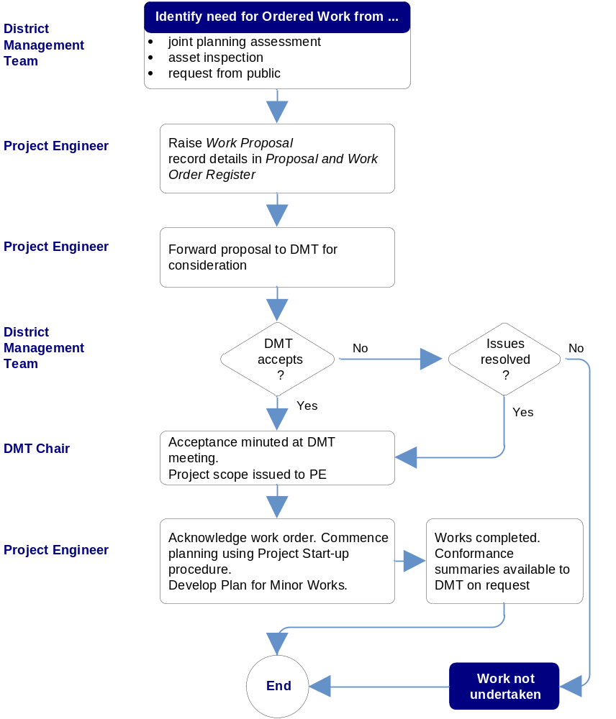
TfNSW District Management Team (DMT)

Project Coordinator

Project Coordinator

TfNSW Contract Manager

TfNSW

TfNSW Contract Manager

Roads Manager

